**How to trigger a Jenkins build from Github using a Webhook trigger**

Step 1:

Create EC2 instance and install Jenkins, docker.

First we need to install Jenkins.

<https://www.jenkins.io/doc/tutorials/tutorial-for-installing-jenkins-on-AWS/>

Follow steps in below link to install docker in Amazon Linux.

<https://www.cyberciti.biz/faq/how-to-install-docker-on-amazon-linux-2/>

Step 2:

Link: <https://dashboard.ngrok.com/get-started/setup/linux>

Install github plugin in Jenkins.

Manage Jenkins -> plugin -> Available plugin -> Search github-> install

Step 4:

We can create the Jenkins job to tigger from github.

Login to jenkin UI and create new pipeline.

New item -> Give name -> pipeline

Under Tigger select ‘Github hook trigger”

Under pipeline we can give our pipeline script.

Step 5:

Now we can create webhook in github for the repo.

Go inside the repository and click on setting.

Then click on webhook -> Add webhook

Give the Jenkins server url/github-webhook/. Then select “Just the push event”. It means whenever push is happened to repo it will tigger job.

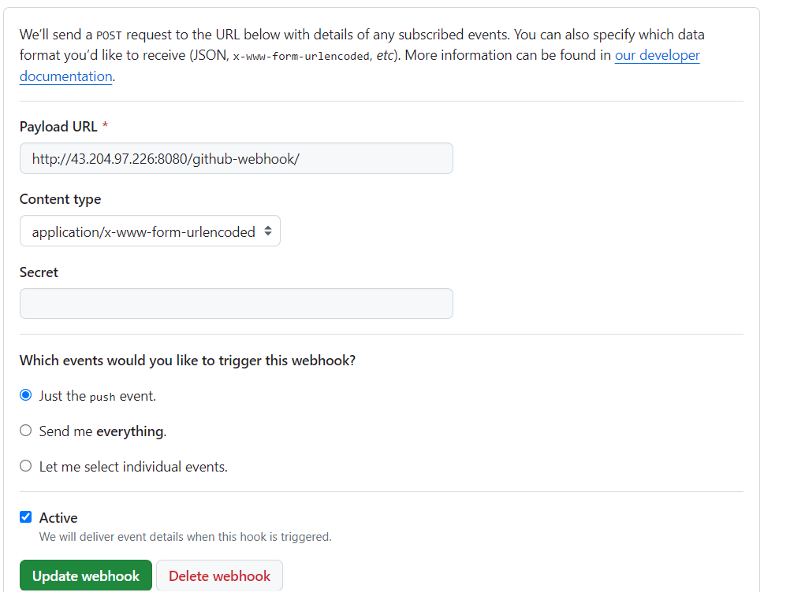

Webhook created and it is connected to

Step 6:

Now we update any file in repository and commit it.

We are updating the heading in index.html.

We can see job is automatically triggered in Jenkins.

Automatically job deployed.

